



**eInvoicing Viewer   
Integration with PEPPOL**

**Quick User Guide**

**DIGIT ISA2 Programme**

**Directorate-General for Informatics ec.europa.eu/isa2**



***ISA2***

**DISCLAIMER**

This document is for informational purposes only and the Commission cannot be held responsible for any use which may be made of the information contained therein. References to legal acts or documentation of the European Union (EU) cannot be perceived as amending legislation in force or other EU documentation.

The document contains a brief overview of technical nature and is not supplementing or amending terms and conditions of any procurement procedure; therefore, no compensation claim can be based of the contents of the present document.

The information and views set out in this publication are those of the author(s) and do not necessarily reflect the official opinion of the European Commission. The European Commission does not guarantee the accuracy of the data included in this document. Neither the European Commission nor any person acting on the European Commission’s behalf may be held responsible for the use which may be made of the information contained therein

**EUROPEAN COMMISSION**

Directorate-General for Informatics

Directorate B — Interoperability Solutions for public administrations, businesses and citizens

Unit B6 — ISA2 Programme

*Contact:* Marco Martini

*E-mail:* [Marco.MARTINI@ec.europa.eu](mailto:Marco.MARTINI@ec.europa.eu)

*European Commission  
B-1049 Brussels*

|  |
| --- |
| ***EUROPE DIRECT is a service to help you find answers***  ***to your questions about the European Union***  Freephone number (*): 00 800 6 7 8 9 10 11  (*) The information given is free, as are most calls (though some operators, phone boxes or hotels may charge you) |

**LEGAL NOTICE**

This document has been prepared for the European Commission however it reflects the views only of the authors, and the Commission cannot be held responsible for any use which may be made of the information contained therein.

More information on the European Union is available on the Internet (http://www.europa.eu).

Luxembourg: Publications Office of the European Union, 2014

|  |  |  |  |  |
| --- | --- | --- | --- | --- |
| Print | ISBN [number] | ISSN [number] | doi:[number] | [Catalogue number] |
| PDF | ISBN [number] | ISSN [number] | doi:[number] | [Catalogue number] |
| EPUB | ISBN [number] | ISSN [number] | doi:[number] | [Catalogue number] |

© European Union, 2018

Reproduction is authorised provided the source is acknowledged.

*Printed in* [Country]

Printed on elemental chlorine-free bleached paper (ecf)

Printed on totally chlorine-free bleached paper (tcf)

Printed on recycled paper

Printed on process chlorine-free recycled paper (pcf)

Image(s) © DIGIT B4, 2018

DOCUMENT METADATA

|  |  |
| --- | --- |
| **Property** | **Value** |
| Release date: | *July 2018* |
| Version: | *v2.2.0* |
| Status: | *Published in joinup* |
| Authors: | *Peter VANDEN BULCKE* |
| Keywords (to increase the SEO presence) | *open e-Prior, eInvoicing, UBL, Invoices, Credit Notes, Attached Documents, PEPPOL, e-TrustEx, bundle, Directive 2014/55/EU* |

The ISA² programme supports the development of digital solutions that enable public administrations, businesses and citizens in Europe to benefit from interoperable cross-border and cross-sector public services.

ISA² is running from **1 January 2016** until **31 December 2020**. The programme was adopted in November 2015 by the European Parliament and the Council of European Union.

Solutions developed by ISA² **and under its predecessor ISA** are generally available for **free** and can be found here.

Under the ISA² programme, the following **actions are supported:** ISA² action overview page.

EXECUTIVE SUMMARY

|  |  |
| --- | --- |
| Short Abstract  (150 words) | Underlying document provides a description of eInvoicing Viewer's functionalities.  The eInvoicing Viewer is a solution that allows users to view electronic invoices received via the PEPPOL network. The new viewing capability is the result of integration of an e-PRIOR component that connects to the PEPPOL network (allowing the reception of eInvoicing business documents compliant with the UBL 2.1 syntax released previously) and reuse of e-PRIOR generic viewer capability of the eTrustEx platform (developed and maintained by DIGIT D3 unit of the European Commission). |
| Objectives  (150 words) | This document is meant to provide instructions on the use of the functionalities of the of eInvoicing Viewer's GUI. |
| Method  (300 words) | Every GUI window is described by :   1. A high level definition 2. A detailed list + breakdown of the window elements 3. A step-by-step guide to the functionalities. |
| Conclusions  (150 words) | Directive 2014/55/EU has enforced that any public administration in Europe shall accept electronic invoices respecting the European Norm by November 2019.  In order to help administrations meet this goal and following requests of some countries, Open e-Prior has built a release that incorporates a viewer of UBL2.1 invoices in addition to the gateway to the PEPPOL network as a first step to alignment to the e-Invoicing European Norm . |

AUDIENCE

This document describes the eInvoicing Viewer's functionalities new for v2.2.0

This document is intended for the following audiences:

|  |  |  |
| --- | --- | --- |
| **AUDIENCE** | | **TARGETED IN THIS DOCUMENT** |
| **POLICY OFFICERS** |  |  |
| **IT PROVIDERS** |  |  |
| **SERVICE PROVIDERS** |  |  |
| **IT ARCHITECTS** |  |  |
| **COMM EXPERTS** |  |  |
| **LEGAL OFFICERS** |  |  |

CONTENTS

1 eInvoicing Viewer 7

1.1 Objective 7

1.2 Based on existing TrustEx Web components 7

1.3 Functionalities 8

1.4 Business advantages 8

2 Browser Requirements 9

3 Monitoring the reception of Invoices/Credit Notes 10

3.1 Inbox 10

3.2 Window Elements 10

3.3 How to display Bundle content 11

4 Exploring and downloading the content of incoming Invoice / Credit Note messages 12

4.1 Received Message 12

4.2 Window Elements 12

4.3 Downloading Invoices / Credit Notes and related Attachments 13

# eInvoicing Viewer

## Objective

A solution has been put in place to allow viewing eInvoices, Credit Notes and Attached Documents received through the PEPPOL network and based on an Open Source software module (eTrustEx Web). This will allow Contracting Authorities to have a basic/low cost solution to be prepared for the alignment to the Directive 2014/55/EU eInvoicing Directive.

## Based on existing TrustEx Web components

In addition to a component to connect e-PRIOR to the PEPPOL network (allowing the reception of eInvoicing business documents compliant with the UBL 2.1 syntax released previously), e-Prior reuses a generic viewer capability (eTrustEx WEB component) of the eTrustex platform, developed and maintained by DIGIT D3 unit of the European Commission, to provide a new capability allowing users to view electronic invoices received via the PEPPOL network.

A Prezi presentation of the PEPPOL eDelivery integration in the eInvoicing Viewer can be viewed at [PEPPOL eDelivery: how it works](https://prezi.com/d92orvsm2bzy/peppol-edelivery-how-it-works/).

[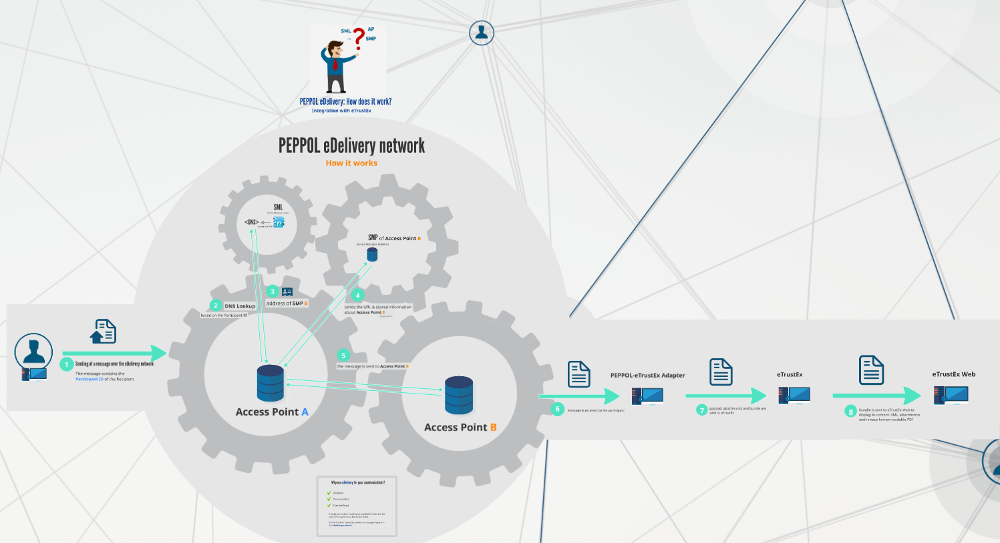](https://prezi.com/d92orvsm2bzy/peppol-edelivery-how-it-works/)

* IMPORTANT :

The parent e-TrustEx Web solution, which eInvoicing Viewer draws upon, offers functionalities that are much wider in range and that are already operational at a platform offered to the EU Institutions as a service and to the Member States as an open source software tool.

A generic guide to eTrustEx Web has been drafted by the European Commission's DIGIT D3 unit. It describes all eTrustEx Web features and can be found with the [eTrustEx Web User Guides](https://webgate.ec.europa.eu/CITnet/confluence/display/ETRUSTEX/eTrustEx+Web+User+Guides).

## Functionalities

eInvoicing Viewer's scope reuses only part of the eTrustEx Web's functionalities, namely:

* Browsing the content of document (eInvoices / Credit Notes) bundles in the INBOX
* Exploring the content of a selected bundle (Invoices / Credit Notes / Attachments)
* Downloading the content of the selected bundle (Invoices / Credit Notes / Attachments)

Underlying document provides a description of eInvoicing Viewer's functionalities.

## Business advantages

The Directive 2014/55/EU has enforced that any public administration in Europe shall accept electronic invoices respecting the European Norm by November 2019.

In order to help administrations meet this goal and following requests of some countries, Open e-Prior has built a release that incorporates a viewer of UBL2.1 invoices in addition to the gateway to the PEPPOL network as a first step to alignment to the e-Invoicing European Norm.

This release provides:

* either a transitional solution for administrations not yet prepared for the Directive giving them a rudimentary tool to access and view invoices received from the PEPPOL network.
* and/or a back-up solution to access and view received invoices
* or a solution to test the reception of PEPPOL invoices by their own solution.

### Why use eInvoicing viewer with ePEPPOL eDelivery Network integration?

The motives for implementing the eInvoicing Viewer integrated with the PEPPOL eDelivery Network are the clear advantages it offers:

* It provides a basic/low cost solution addressed to any public administration in view of compliance with OpenPEPPOL implementation of Directive 2014/55/EU.
* It relies on a Secured transport infrastructure.
* It supports national and Cross-border invoices compliant with the EN 16931 received through the OpenPEPPOL network.
* It is an Open Source solution and based on standards.

# Browser Requirements

|  |  |  |  |
| --- | --- | --- | --- |
| Browser | | Required | Additional information |
|  | Chrome | 64 |  |
|  | Firefox | 59 | Requires these 2 preferences to be enabled in about:config.   * javascript.option.streams * dom.streams.enabled |
|  | Edge | 17 | This is the EdgeHTML version.  Edge is only available in Windows 10 |

# Monitoring the reception of Invoices/Credit Notes

## Inbox

The Inbox window displays all Invoices, Credit Notes and Attached Documents sent by Suppliers through the PEPPOL network.

The Inbox content displayed to the user is restricted to the Contracting Authority and the business domain that he is configured for. Rules and method of configuration can be found in the guide " e-TrustEx Web - WildFly installation and configuration". .

From the Inbox the user can display messages by double-clicking them (see 3.3).

## Window Elements

|  |  |  |
| --- | --- | --- |
| **N°** | **GUI Element** | **Description** |
| **1** | Language Selector | Use this combo box to select the preferred interface language |
| **2** | Party | This field displays the Recipient Contracting Authority. |
| **3** | Inbox | Click this folder to display a list of received Invoices/Credit Notes |
| **4** | Sent | In the eInvoicing Viewer use of this functionality is out of scope |
| **5** | Draft | In the eInvoicing Viewer use of this functionality is out of scope |
| **6** | Refresh | Click this button to refresh the list of displayed Invoices/Credit Notes |
| **7** | Subject | Use this field to search for Invoices/Credit Notes by (part of) their name. |
| **8** | Received | Click this button to sort Invoices/Credit Notes by date received. |
| **9** | Message Name | This field displays the name of Invoices/Credit Notes, the sender and the date/time received. |
| **10** | Attachment icon | This icon indicates that the Invoice/Credit Note carries one or more documents attached. |
| Warning icon red | A red warning icon indicates that the attachments expired due to the retention policy (Usually, after 12 weeks attachments are no longer available to the user. This period is configurable. Read how in the guide " e-TrustEx Web - WildFly installation and configuration".). |
| Warning icon yellow | A yellow warning icon indicates that the attachments are set to expire on a specific date. |
| **11** | All / Unread | Click this button to display the required list of Invoices/Credit Notes |

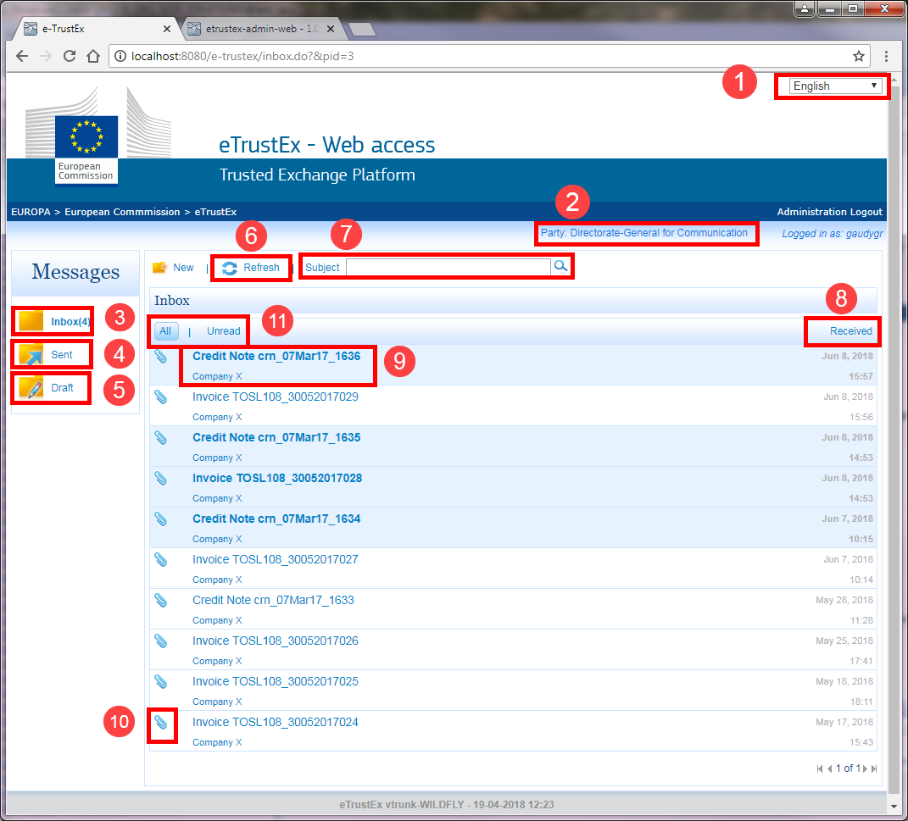

1. Inbox window: fields

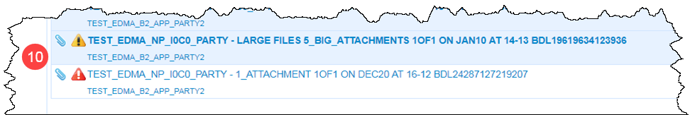

1. Attachments and Expiry warnings

## How to display Bundle content

To display the content of a bundle proceed as follows:

1. In the Inbox click the Invoice / Credit Note  Name.

The Received Message window is displayed (see Fig. 3).

* Note:

From the Received Message window users can access human readable files. How to, see 4.3.

# Exploring and downloading the content of incoming Invoice / Credit Note messages

## Received Message

Messages are business documents, i.e. Invoices, Credit Notes and attached documents. They are sent in bundles and are compliant with the UBL 2.1 syntax. The Received Message window displays:

* information on individual Invoice / Credit Note messages.
* information on the files (invoices/credit notes and their related attachments) that compose the document bundle.

From the received Message window users can also download human readable versions.

* IMPORTANT:

The invoices / credit notes are received through the PEPPOL network and are structured in UBL 2.1 syntax. From this structure the software integration developed in the provided eInvoicing Viewer solution automatically generates a PDF version, which is human readable and much more user-friendly. It is these automatically generated documents that are the documents on which users will normally focus their attention.

## Window Elements

|  |  |  |
| --- | --- | --- |
| **N°** | **GUI Element** | **Description** |
| **1** | Received Message pane | This pane repeats the Invoice / Credit Note message data from the Message Name in the Inbox |
| **2** | Subject | This field displays the Message Name. |
| **3** | From | This field displays the Sender's Name. |
| **4** | Received on | This field displays the date/time the Invoice / Credit Note message was received. |
| **5** | Comments pane | This pane is out of scope. |
| **6** | List of Files pane | This pane displays the files related to the Invoice / Credit Note message, and selection options. |
| **7** | List of Files field | This field displays the files related to the Invoice / Credit Note message, and individual check boxes.  Files in this field can be downloaded. |
| **8** | Download selected files | Click this button to collect the selected files in a Bundle and download it to the browser's default Downloads location. |
| **9** | Return to messages | Click this button to return to the Inbox. |

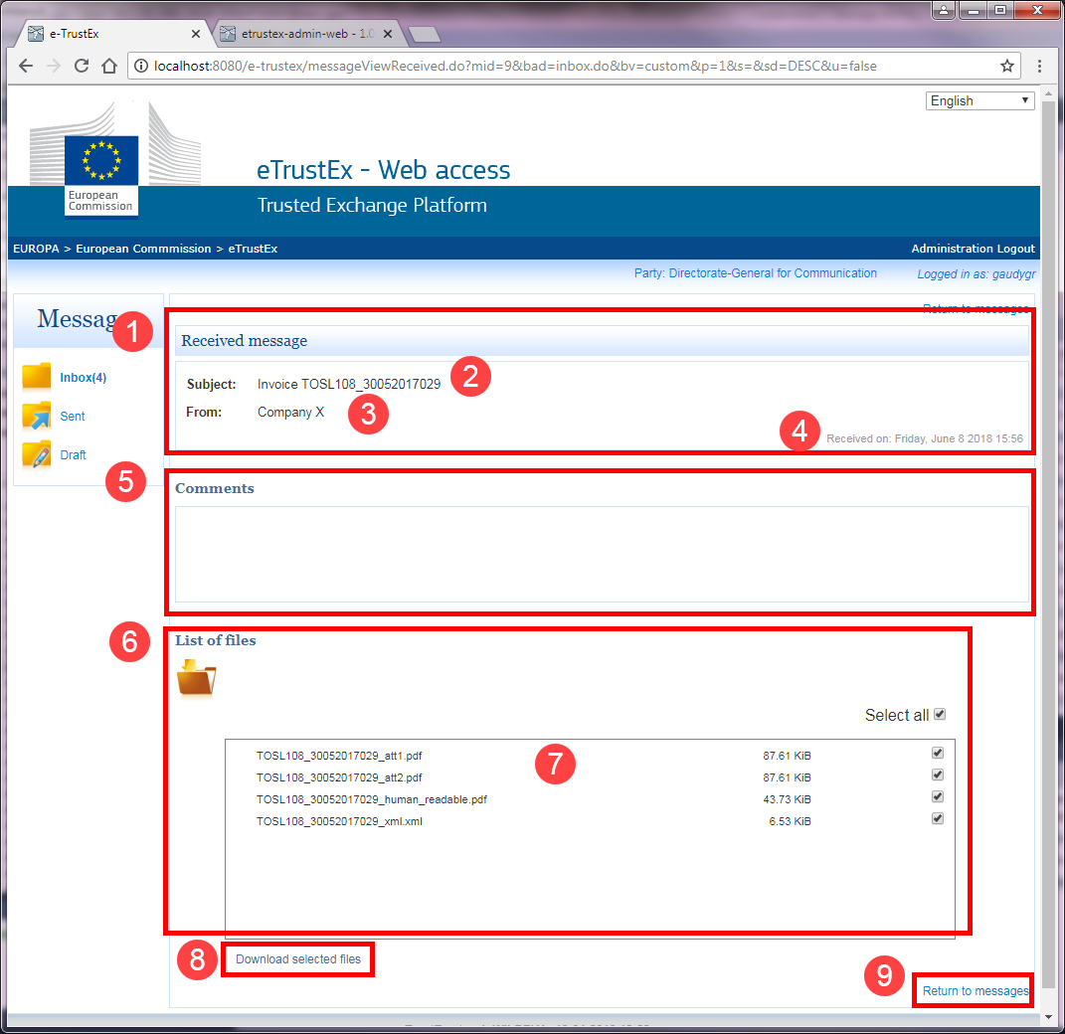

1. Received Message window

## Downloading Invoices / Credit Notes and related Attachments

The eInvoicing Viewer offers the possibility to download files attached to the messages that it displays.

To download files attached, proceed as follows:

1. In the Received Message window navigate to the List of Files pane.

The "Select all" checkbox is checked by deault.

1. In the List of Files pane, if necessary, **uncheck** the "Select all" checkbox, and **check** only those files you want to download.
2. Click the Download selected files button.

The selected file(s) is/are collected in a Bundle.

The Download progress bar dialog box is displayed.

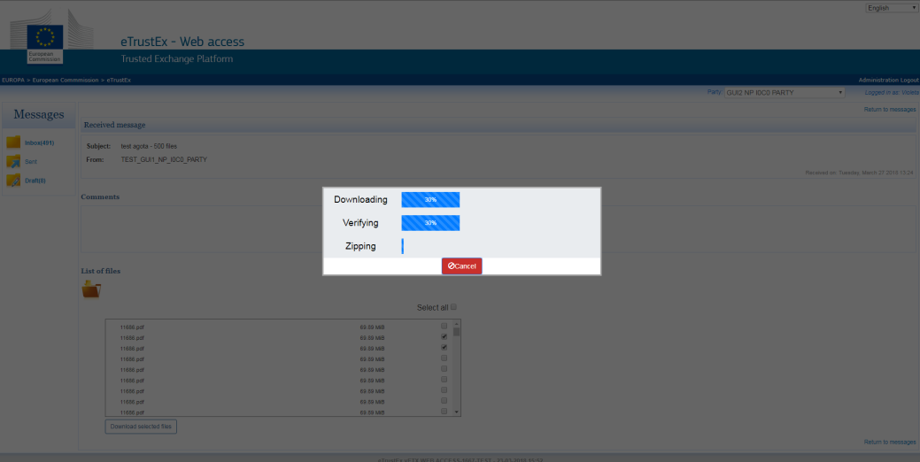

1. Download progress bar dialog box

* NOTE

The Download progress bar dialog box has 3 progress bars that denote the following actions:

* + file downloading
  + file integrity verification
  + file archiving

1. The Download progress bar dialog box closes automatically once the Bundle has been downloaded.

The Bundle is downloaded in the **browser's default Downloads** location.

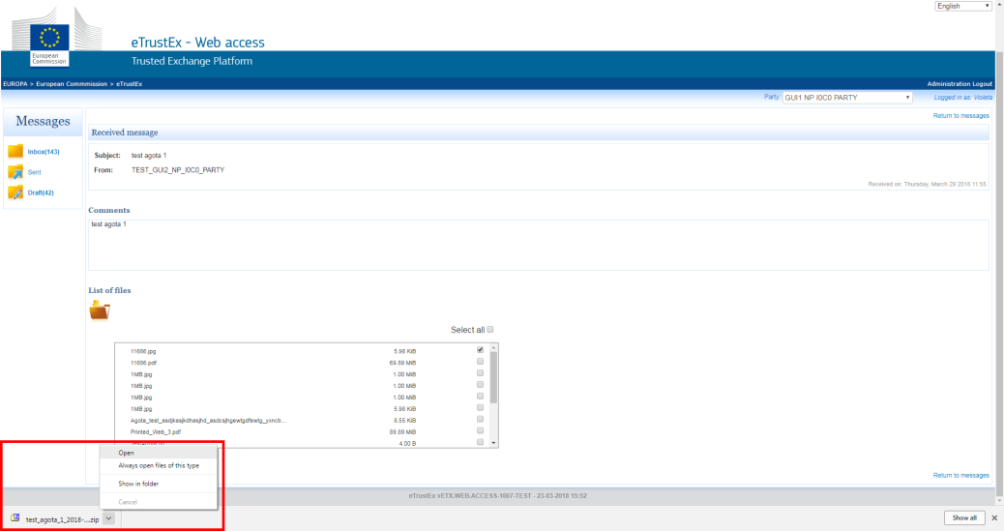

1. Downloaded files viewing
2. To process the files in the Bundle, click the browser's downloads bar, and select one of the following options:

|  |  |
| --- | --- |
| **Option** | **Actions** |
| To **view directly** | 1. Select Open |
| To view in the **Downloads folder** | 1. Select Show in folder.   The Downloads folder is displayed.   1. Double-click the ZIP folder. |

The ZIP file is opened displaying the downloaded attachments.

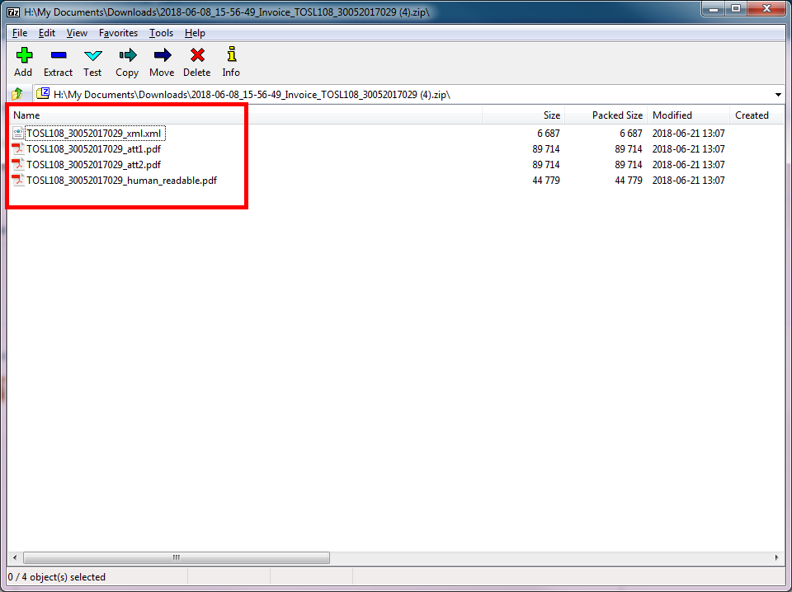

1. Double-click a file.

The file is displayed in the associated application.

* IMPORTANT:

The invoices / credit notes are received through the PEPPOL network and are structured in UBL 2.1 syntax. From this structure the software integration developed in the provided eInvoicing Viewer solution automatically generates a PDF version, which is human readable and much more user-friendly. It is these automatically generated documents that are the documents on which users will normally focus their attention.

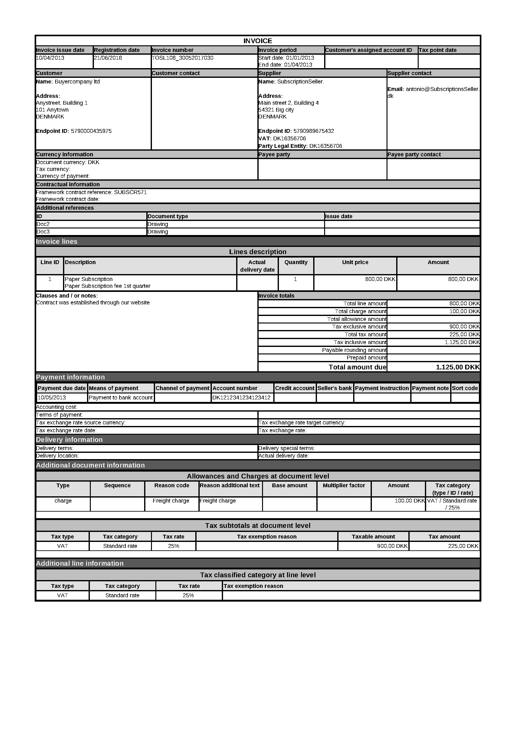

1. Human readable PDF of UBL 2.1 syntax (invoice type)

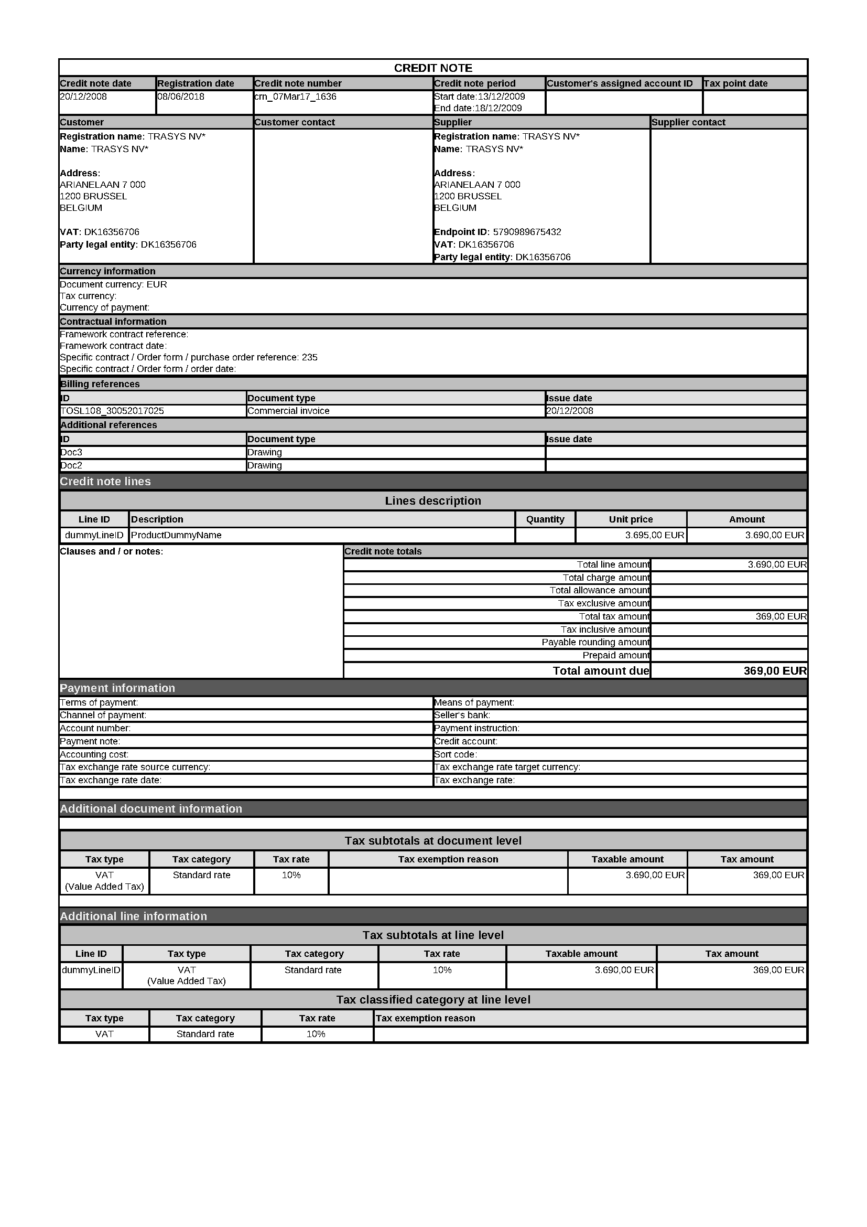

1. Human readable PDF of UBL 2.1 syntax (credit note type)